Students Name: …………………………………………………………………
School Name:…………………………………… Index Number ……………
612/4
FINE ART
PAPER 4
Nov/Dec 2020
5 Hours
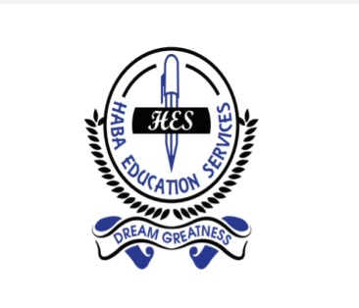
HES MOCK EXAMINATIONS 2020
UGANDA CERTIFICATE OF EDUCATION
FINE ART
IPS612/4.
5 hours

Time; Sketching session – 2 Hours
Practical Examination – 3 Hours

.
Attempt one number

- Riots
- Harvesting Matooke
- Mother’s love
- Kadodi Dance
- My sister’s birthday
- A visit to the market in Owino
- An accident

END

